MANAGING WORKFORCE FLOW seminar

Onboarding Hilton – Case study
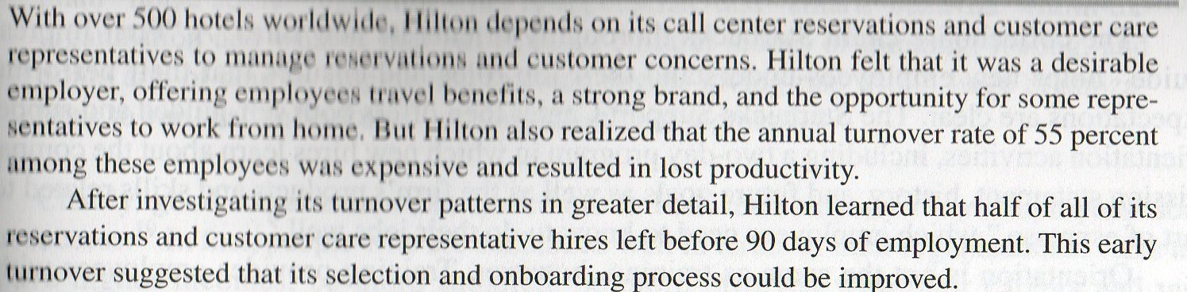
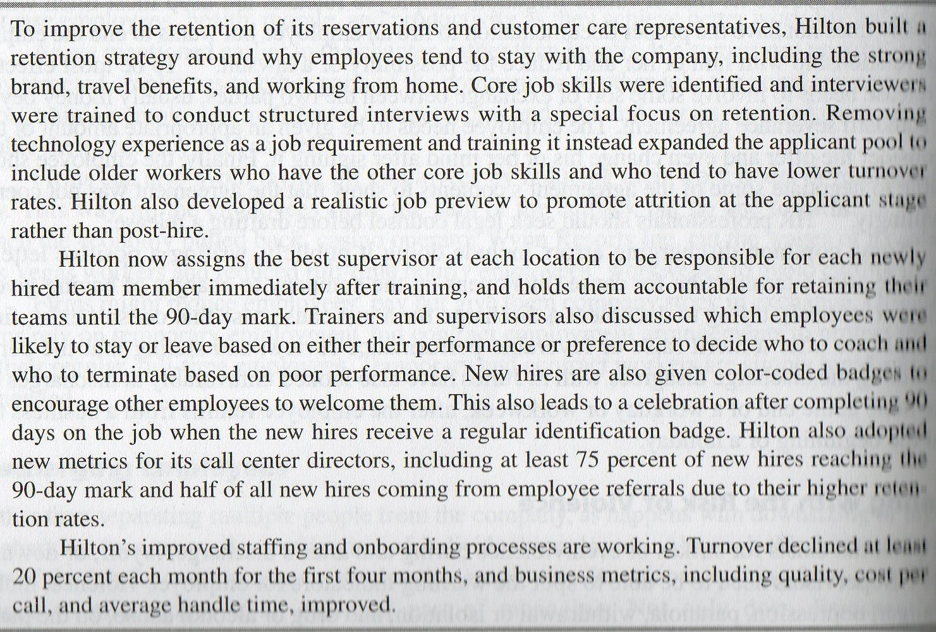
1. What are the strength of Hilton’s socialization program and why?
2. Do you think that is it appropriate for Hilton to hold supervisors accountable for employee retention during the first 90 days? Why or why not?
3. What additional ideas do you have to quickly socialize new employees into a company focused on customer service?

The IndyMAc Bank case
