**Practicing exercises – No. 2.**

**Ágnes Kotsis**

**1. Linear programming.**

**Exercise 3.** The table below contains data about production opportunities, and market constraints.

|  |  |  |  |
| --- | --- | --- | --- |
|  | **P1** | **P2** | **b (hs/y)** |
| **R1** | 2 | 4 | 7000 |
| **R2** | 5 | 2 | 6500 |
| **E3** | 2 | 2 | 5000 |
| **MIN (pcs/y)** | 400 | 500 |  |
| **MAX (pcs/y)** | 1000 | 1500 |  |
| **P ($/pcs)** | **120** | **40** |  |
| **CM($/pcs)** | **30** | **30** |  |

***a) According to the manufacturing opportunities and the market’s constraints, determine the optimal product mix, if we want to maximize our revenues.***

***b) According to the manufacturing opportunities and the market’s constraints, determine the optimal product mix, if we want to maximize our profit.***

**2. Scheduling.**

A workstation has to produce 5 different products’ processing time and due date for each product is contained by the matrix below.

|  |  |  |
| --- | --- | --- |
| **Product** | **Processing time (day)** | **Due date (day)** |
| **A** | 10 | 12 |
| **B** | 7 | 10 |
| **C** | 8 | 6 |
| **D** | 12 | 20 |
| **E** | 11 | 15 |

***a) Determine the proper sequence of the products with the help of using***

FCFS rule: ……-……-……..-……-……..

SPT rule: ……-……-……..-……-…….

EDD rule: ……-……-……..-……-…….

CR rule: ……-……-……..-……-…….

***b) Determine the average flow time, average tardiness, and average number of jobs at the work center.***

|  |  |  |  |
| --- | --- | --- | --- |
|  | Aft | At | Aj |
| FCFS | ……………… | ……………… | ……………… |
| SPT | ……………… | ……………… | ……………… |
| EDD | ……………… | ……………… | ……………… |
| CR | ……………… | ……………… | ……………… |

***c) Compare the results of the four rules? Which is the best? Why?***

……………………………………………………………………………………………………………………………………………………………………………………………………………………………………………………………………………………………………………………………………………………………………………………………………………………………………………………………………………………………………………

**SOLUTION**

**Exc. 1.**

Resource costraints:



market constraints:



Figure is the following:

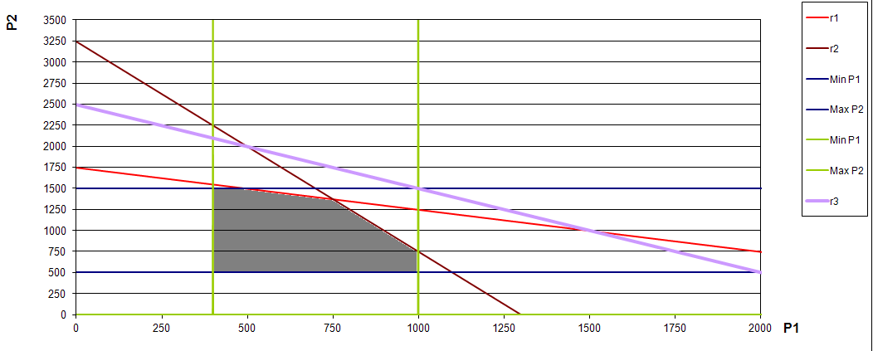Than we determine the objective function:

When we maximize revenue

 (pink line)

Shift it toward the feasible area (grey area) to find the tangent point. That will be the optimum point.

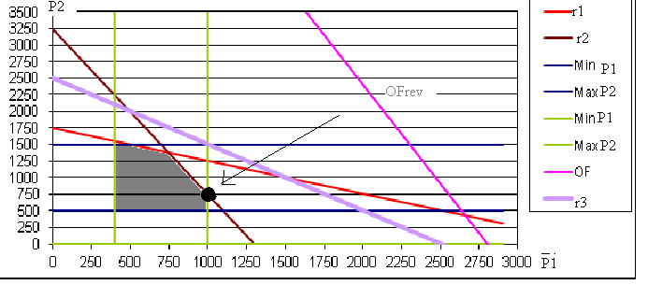

It is in the section of r2 and min P1:

, solve this equation system. The result is: P1=1000, P2=750

When we are looking for the point that represent maximal profit, our OF is:

 (pink line)

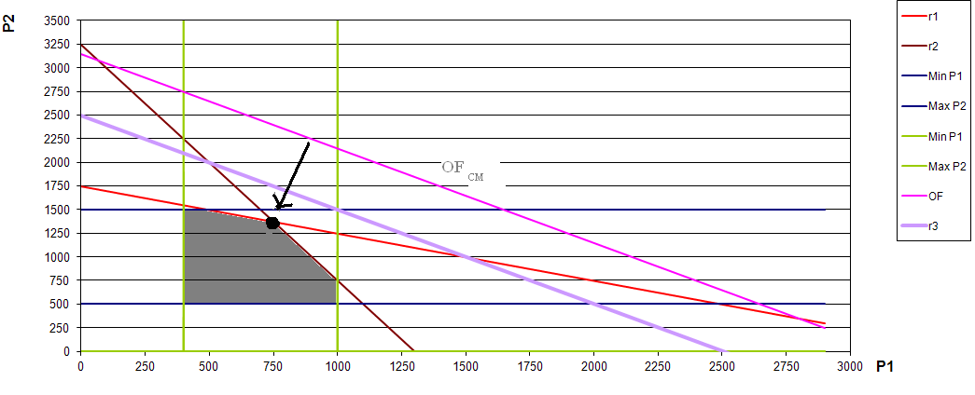

The optimal point is in the intersecrion of r2 and r1:

solve this equation system.



The result is P1=750 and P2=1325 pieces.

**Exc 2.**

**FCFS: ABCDE**

|  |  |  |  |  |
| --- | --- | --- | --- | --- |
| **Product** | **Processing time (day)** | **Due date (day)** | **Total flow time** | **Tardiness** |
| **A** | 10 | 12 | 10 | 0 |
| **B** | 7 | 10 | 17 | 7 |
| **C** | 8 | 6 | 25 | 19 |
| **D** | 12 | 20 | 37 | 17 |
| **E** | 11 | 15 | 48 | 33 |
| 5 | 48 |  | 137 | 76 |



**SPT: BCAED**

|  |  |  |  |  |
| --- | --- | --- | --- | --- |
| **Product** | **Processing time (day)** | **Due date (day)** | **Total flow time** | **Tardiness** |
| **B** | 7 | 10 | 7 | 0 |
| **C** | 8 | 6 | 15 | 9 |
| **A** | 10 | 12 | 25 | 13 |
| **E** | 11 | 15 | 36 | 21 |
| **D** | 12 | 20 | 48 | 28 |
| 5 | 48 |  | 131 | 71 |



**EDD: CBAED**

|  |  |  |  |  |
| --- | --- | --- | --- | --- |
| **Product** | **Processing time (day)** | **Due date (day)** | **Total flow time** | **Tardiness** |
| **C** | 8 | 6 | 8 | 2 |
| **B** | 7 | 10 | 15 | 5 |
| **A** | 10 | 12 | 25 | 13 |
| **E** | 11 | 15 | 36 | 21 |
| **D** | 12 | 20 | 48 | 28 |
| 5 | 48 |  | 132 | 69 |



**CR:**

|  |  |  |  |  |  |  |  |  |
| --- | --- | --- | --- | --- | --- | --- | --- | --- |
| **Product** | **Processing time (day)** | **Due date (day)** | **CR0** | **CR8** | **CR15** | **CR25** | **CR36** |  |
| **A** | 10 | 12 | 1,200 | 0,4 | -0,3 | third | third | third |
| **B** | 7 | 10 | 1,429 | 0,285714 | second | second | second | second |
| **C** | 8 | 6 | 0,750 | first | first | first | first | first |
| **D** | 12 | 20 | 1,667 | 1 | 0,416667 | -0,41667 | -1,66667 | fifth |
| **E** | 11 | 15 | 1,364 | 0,636364 | 0 | -0,90909 | fourth | fourth |

CR: CBAED it is similar to the EDD rule.



**c)**

The best is the SPT rule because it is better in two dimensions than the other rules.